Mission 1: CodeSpace Assignment | Name:
Label the parts of CodeSpace.
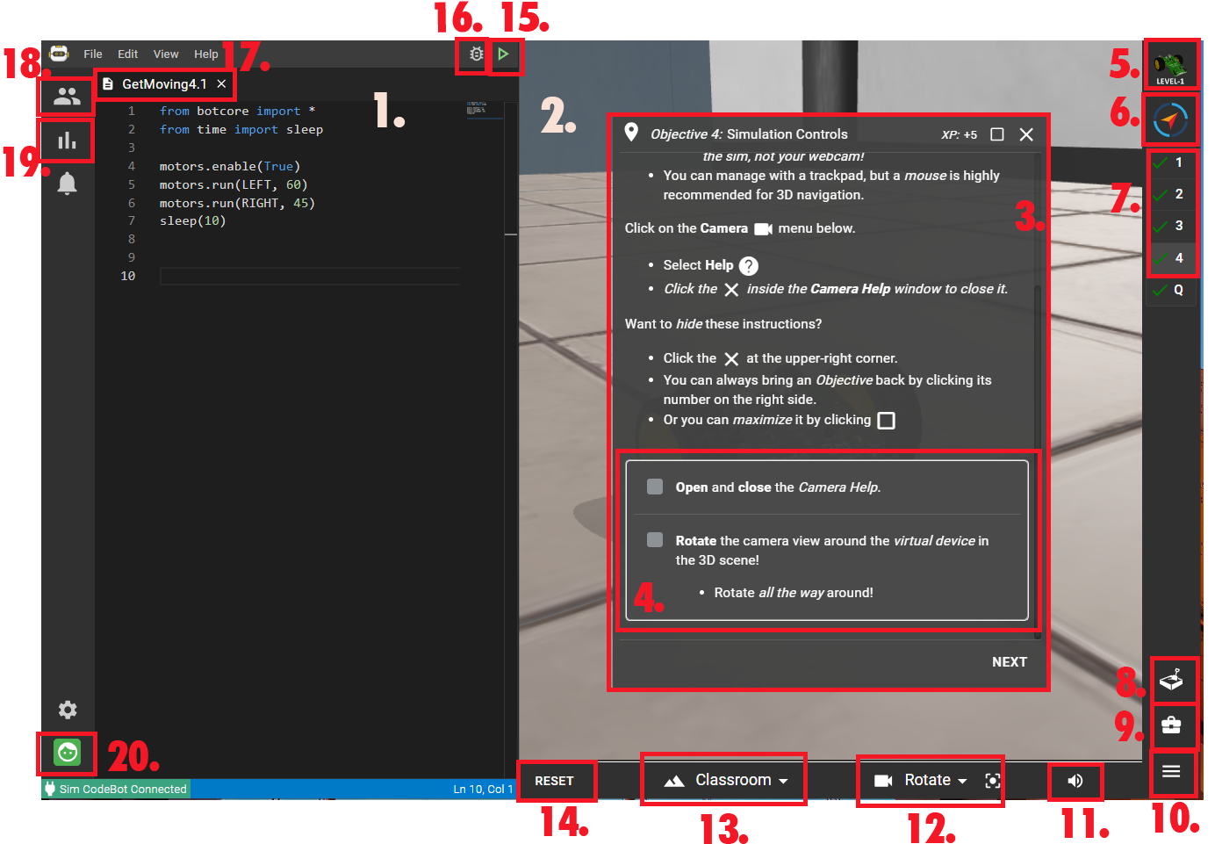
1. | 11.
2. | 12.
3. | 13.
4. | 14.
5. | 15.
6. | 16.
7. | 17.
8. | 18.
9. | 19.
10. | 20.

Parts of CodeSpace:
- Goals
- Objectives or Mission panel
- Camera controls
- Debugger
- Select Class
- Text Editor
- Log in / out
- 3D environment
- Filename
- Console panel
- Reset the environment
- Current Mission Pack
- Run program
- Objective panel
- Sandbox
- Progress and contests
- Toolbox
- Current Mission
- Select 3D environment
- Scene volume

